Homework: 12 Years A Slave official trailer, Steve McQueen, 2013

Go to Youtube and watch the official trailer of the movie 12 Years A Slave by Steve McQueen by entering the following request (“12 Years A Slave official trailer”) and clicking on the first non-commercial link.

- Where is Solomon Northup from and what is his legal status before 1840?
________________________________________________________________________________________________________________________________________________________________________________________________

- What happens to him in 1841?
________________________________________________________________________________________________________________________________________________________________________________________________

- What are the keywords of this excerpt?
_________________________________________________________________________________________________________________________________________________________________________________________________

Homework: 12 Years A Slave official trailer, Steve McQueen, 2013

Go to Youtube and watch the official trailer of the movie 12 Years A Slave by Steve McQueen by entering the following request (“12 Years A Slave official trailer”) and clicking on the first non-commercial link.

- Where is Solomon Northup from and what is his legal status before 1840?
________________________________________________________________________________________________________________________________________________________________________________________________

- What happens to him in 1841?
________________________________________________________________________________________________________________________________________________________________________________________________

- What are the keywords of this excerpt?
_________________________________________________________________________________________________________________________________________________________________________________________________

Homework: 12 Years A Slave official trailer, Steve McQueen, 2013

Go to Youtube and watch the official trailer of the movie 12 Years A Slave by Steve McQueen by entering the following request (“12 Years A Slave official trailer”) and clicking on the first non-commercial link.

- Where is Solomon Northup from and what is his legal status before 1840?
________________________________________________________________________________________________________________________________________________________________________________________________

- What happens to him in 1841?
________________________________________________________________________________________________________________________________________________________________________________________________

- What are the keywords of this excerpt?
_________________________________________________________________________________________________________________________________________________________________________________________________

Homework: 12 Years A Slave official trailer, Steve McQueen, 2013

Go to Youtube and watch the official trailer of the movie 12 Years A Slave by Steve McQueen by entering the following request (“12 Years A Slave official trailer”) and clicking on the first non-commercial link.

- Where is Solomon Northup from and what is his legal status before 1840?
________________________________________________________________________________________________________________________________________________________________________________________________

- What happens to him in 1841?
________________________________________________________________________________________________________________________________________________________________________________________________

- What are the keywords of this excerpt?
_________________________________________________________________________________________________________________________________________________________________________________________________

Worksheet: what was Solomon Northup’s journey through the United States?
Instruction: Using the excerpts below, find the locations on the map and draw Solomon’s journey through the 1840 United States.
Document 1: Solomon’s birthplace

“Sometime after my father's liberation, he removed to the town of Minerva, Essex County, N.Y., where I was born, in the month of July, 1808”.

Document 2: slave manifest of the Brig Orleans (1841)

“Manifest of Slaves, intended to be transported on board of the Brig Orleans of Richmond, […] and bound from the port of Richmond, State of Virginia, for the Port of New Orleans, State of Louisiana, this 27th day of April, 1841”.

Document 3: the arrival on the estate (1841)

“Edwin Epps […] was in possession of a plantation on Bayou Huff Power. […] His principal business was raising cotton”.

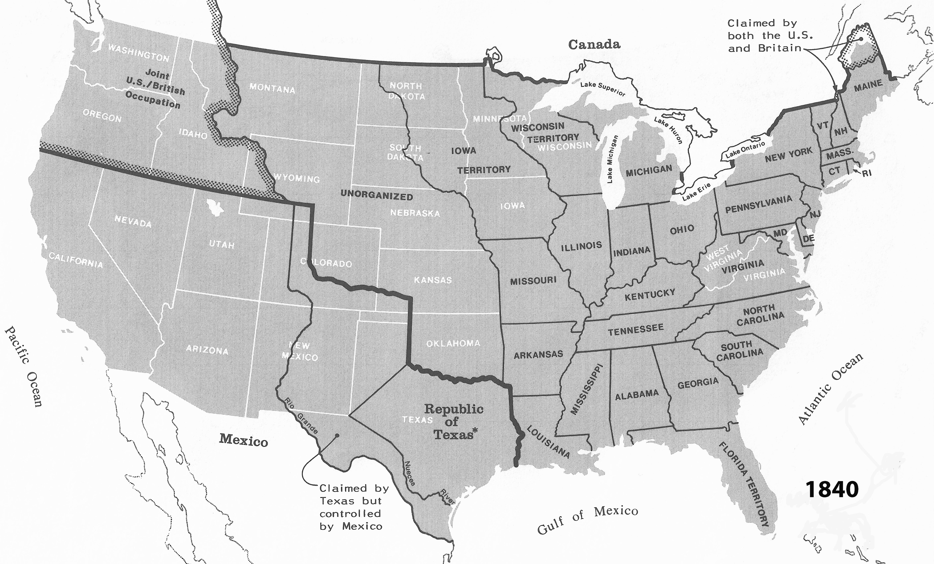
Source: Map Guide to the U.S. Federal Censuses, 1790-1940, by William Thorndale and William Dollarhide, publ. Genealogical Publishing Co., Baltimore, 1987. (For educational purposes only)
Question
How can one be a free man in the North and a slave in the South? What does it tell us about the differences between North and South in the 1840’s U.S.A.?
Worksheet: how does the movie portray the inversion of social values caused by slavery?

Excerpt n°1 – Patsey and Solomon’s dialogue
- Which of the following sentences summarizes best the excerpt?

- Patsey wants to escape from the estate and asks Solomon to help her.
- Solomon refuses to help Patsey escaping the estate.
- Patsey wants to die and begs Solomon for help, which he accepts.
- Patsey wants to die and begs Solomon for help, which he refuses.
Justify: ________________________________________________________________________________________
Excerpt n°2 – Eliza and Solomon’s dialogue
- EVERYTHING’S TRUE! All the statements below are true; justify them by quoting the video.

- Eliza is sad because she has been separated from her children.
_______________________________________________________________________________________________
- Solomon accepts to work as a slave to earn his freedom.
_______________________________________________________________________________________________
- Eliza disagrees with Solomon’s strategy.
_______________________________________________________________________________________________
- Solomon has suffered physical punishment for claiming his freedom.
_______________________________________________________________________________________________

Excerpt n°3 – Solomon’s work for Master Ford
- Read the following sentences and underline the right word.
Solomon proposes to Master Ford to use the (water/land) way to transport wood. It would (reduce/increase) the distance to the work area and (diminish/raise) the costs. The overseer (agrees/disagrees) with this proposal: he thinks the passes are too (tight/large). However, Solomon succeeds in convincing Master Ford thanks to his experience on the Champlain (canal/dam). To express his gratitude, Master Ford offers Solomon a (violin/guitar). Nevertheless, Solomon looks (disappointed/happy): he probably expected a greater (reward/punishment).
Going further…
Connect each value in the first chart below with its opposite. Associate each pair of opposed values to an excerpt.
Excerpt n°1
Excerpt n°2
Excerpt n°3
Death
Obedience
Punishment
Reward
Life
Resistance

Recap lesson 1: how did slavery turn social values upside down?

In the mid-nineteenth century, the USA was divided into _____ parts over the question of slavery: North of the ______________ __________, slavery was ______________; South of the line, it was ____________. Slavery in the South of the United States was very specific: when they arrived on the ______________, the slaves had to survive in a world where social values were turned ___________ _____________. For instance, obedience can be considered as a form of _________________: by obeying the master, the slaves could escape surveillance and maybe hope to regain their _________________, as it was the case for Solomon. On the contrary, resisting the Master could cost the slaves physical _________________. Furthermore, Patsey’s request shows us that __________ was another strategy to avoid slavery: in order to escape violence and oppression, the slaves could sometimes commit ______________ to end their suffering. Finally, even the ______________ given by the Master could be considered as some kind of ___________________: when Solomon receives the violin, it reminds him of his past life as a free man, which makes his slave situation hard to bear.

Louisiana, near the frontier with Texas.

